SWOT Analysis
FOR
CJ’S COOKHOUSE
Columbus, Ohio
2020

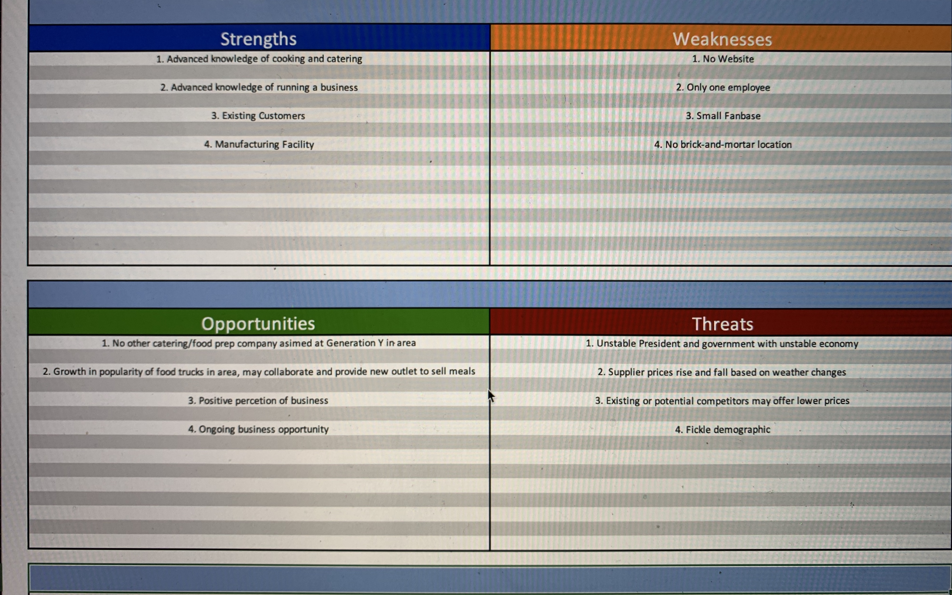
Figure 1: SWOT Analysis Worksheet
Strengths: CJ studied at the Columbus Culinary Institute and worked part time at a catering business in Cleveland. This information will give consumers an extra bit of confidence in the quality of the services offered. Additionally, the professional level kitchen in her home serves as her own manufacturing facility.
Weaknesses: The lack of a website stymies their ability to keep customers informed who may not be on social media. This will be remedied once their website has been created. Additionally, they have a small but loyal following on Facebook and Instagram. This is a weakness because the company needs to be known by more people in order to grow. The campaign will remedy this, because it will be heavily promoted on more social media sites in order to drum up business. Additionally, having only one employee is a weakness because once the business grows, CJ may get overwhelmed with orders.
Opportunities: Capitalizing on the fact that many Millennials have moved to north-central Ohio to live their post-college lives, CJ’s is available to meet their dietary needs. Also, the popularity of food trucks, paired with her personal and professional relationships with many food truck owners, creates a potential new avenue for her creations to be sold. Finally, the positive perception of the catering business, when presented in an upscale way, makes CJ’s even more attractive to consumers, and at one time or another, everyone will need something catered.
Threats: We live in unpredictable time, with an unpredictable President and an unstable economy. Because of this, It can be difficult to gauge how the job market will be in the future. This can directly affect how consumers will spend their money. Adding to that, supplier prices can rise and fall with the change in the weather and how it affects their products. Competition may lower their prices in an attempt to draw customers away from an independent catering business. On top all of these threats, the public is fickle, especially young people. All of these threats could cause the company to be on shaky ground, However, CJ’s plans to keep their pricing as steady as possible, without lowering quality standards.

