COMPANY OVERVIEW
CJ’s Cookhouse, a Columbus, Ohio based catering and food preparation service, will
provide generation Y (as well as others) an option to meet their basic nutritional needs while maintaining their lifestyles. CJ’s offers many choices, from catering to cooking lessons to pre-made meals, that will aid the overloaded Millennial in remaining full and healthy (Simmons, 2018). For CJ’s Cookhouse, social media will be utilized for a campaign on Facebook, Instagram, Twitter and LinkedIn, with the goal of increasing customers and followers within the target market of 25-35-year-old female professionals by 30% (Stanley, 2019).
TARGET MARKET

While open and available to anyone, the target market for this business is the young, urban, African-American female professional, aged 25 to 35, with an income of $75,000 to $100,000 annually. This customer resides in the heart of a metropolitan city, and has (at least) an undergraduate college degree.
Millennials, also known as Generation Y, are young adults aged 18 – 35. This
demographic is not only very upwardly mobile, but they are one of the busiest generations of our time (Carmichael, 2016). Keeping such a busy schedule, both work-based and social, these members of society have shown difficulty meeting their desire to eat healthily and regularly (smithcorona.com, 2019). Between working and very full social calendars, millennials have very little time to attend to basic needs like keeping a proper diet and food preparation (Rosenbloom, 2018).
According to research, Millennials are the most likely age group to eat at restaurants instead of at home (Oyedele, 2018). Additionally, they eat the majority of their meals at restaurants and are most likely to have purchased prepared meals (Oyedele, 2018). The issue with these statistics is that these meals, pre-made or from restaurants, may not be the healthiest.
CJ’s CEO and head chef Chenese Simmons, is a member of Generation Y. She is also a single mother who understands trying to balance a busy lifestyle with providing healthy eating options for herself and her son. Being an understanding consumer makes it easy for Chenese to identify with the needs of her target demographic.
BUYER PERSONA
For the purposes of this analysis, out buyer is Faith Wilson, a Junior Vice President of Marketing for Nationwide Insurance in Columbus, Ohio. Faith makes $95K annually, and owns a condominium in Easton, a small suburb of Columbus. Faith enjoys spending time with her boyfriend Nicolas, practicing yoga and attending a weekly game night with her friends. An avid churchgoer, she is driven by her spirituality and her desire to win at life. Being active on the social media platforms Facebook, LinkedIn, Instagram and Twitter, Faith will use CJ’s meal prep service to not have to cook, but still eat healthy. She will utilize the special meal creation option to prepare romantic dinners for Nicolas, and if things go as planned, she can use the full catering option for her wedding.
Figure 1. Faith, African-American Female Millennial (2020)

COMPETITIVE ANALYSIS

In the North and Central Ohio areas, three different catering companies were found to be competition for CJ’s Cookhouse: Creative Cuisine Catering, in Columbus, Marigold Catering in Cleveland and Milo’s catering, also in Columbus. These were considered as competition based the diversity in their ownerships. Per their website, Marigold Catering is not only woman-owned, but also LGBTQ+-owned (marigoldcatering.com, 2020). However, the business that resembles CJ’s the closest would be Creative Cuisine, because, like CJ’s, they are owned by an African-American woman.
According to the website, Creative Cuisine offers event catering, with special emphasis on weddings. They boast a 12,000 square-foot office and production space that can “handle the most complex events,” (2020). Additionally, the location has an in house rental division, on site floral studio, full bakery and a spectacular tasting kitchen where guests can sample their proposed menu (2020).
Based on the aforementioned information, the WR Franklin, Inc. Public Relations firm will combine what has been used in the past (word of mouth exposure, Facebook and Instagram) with new strategies (an eye-catching website, visibility on LinkedIn and Twitter) to gain more exposure for CJ’s. With these additional outlets, the sky is the limit as far as getting the word further out into the atmosphere about this catering business. Once all of these outlets are up and running, the social media campaign can start across all outlets.

RESEARCH BRIEF

According to Fryrear (2015), surveys that are well-targeted have a higher response rate than those distributed to external audiences. Based on this information, this survey was sent to ten women between the ages of 18 to 35, the age range of Generation Y, via e-mail. This direct approach, specifically targeting the demographic will bring in valuable insight to the client, so she can adjust anything that her company is not doing to line up with the results.
Proposed Questions:
- How health conscious do you consider yourself to be?
- How healthy do you consider the meals you get at restaurants to be?
- While it is a necessity, is meal preparation a convenience, an inconvenience or neither?
- If you were presented with a way to have healthy, pre-made meals (of your own choosing) made to be kept in your freezer for convenience, would you take advantage of the opportunity?
The research used with the results of this survey was Quantitative, as the results can be counted, measured and expressed using numbers. The WR Franklin PR Company is quite confident with the information provided by the sources of the information because we were the company doing the research.

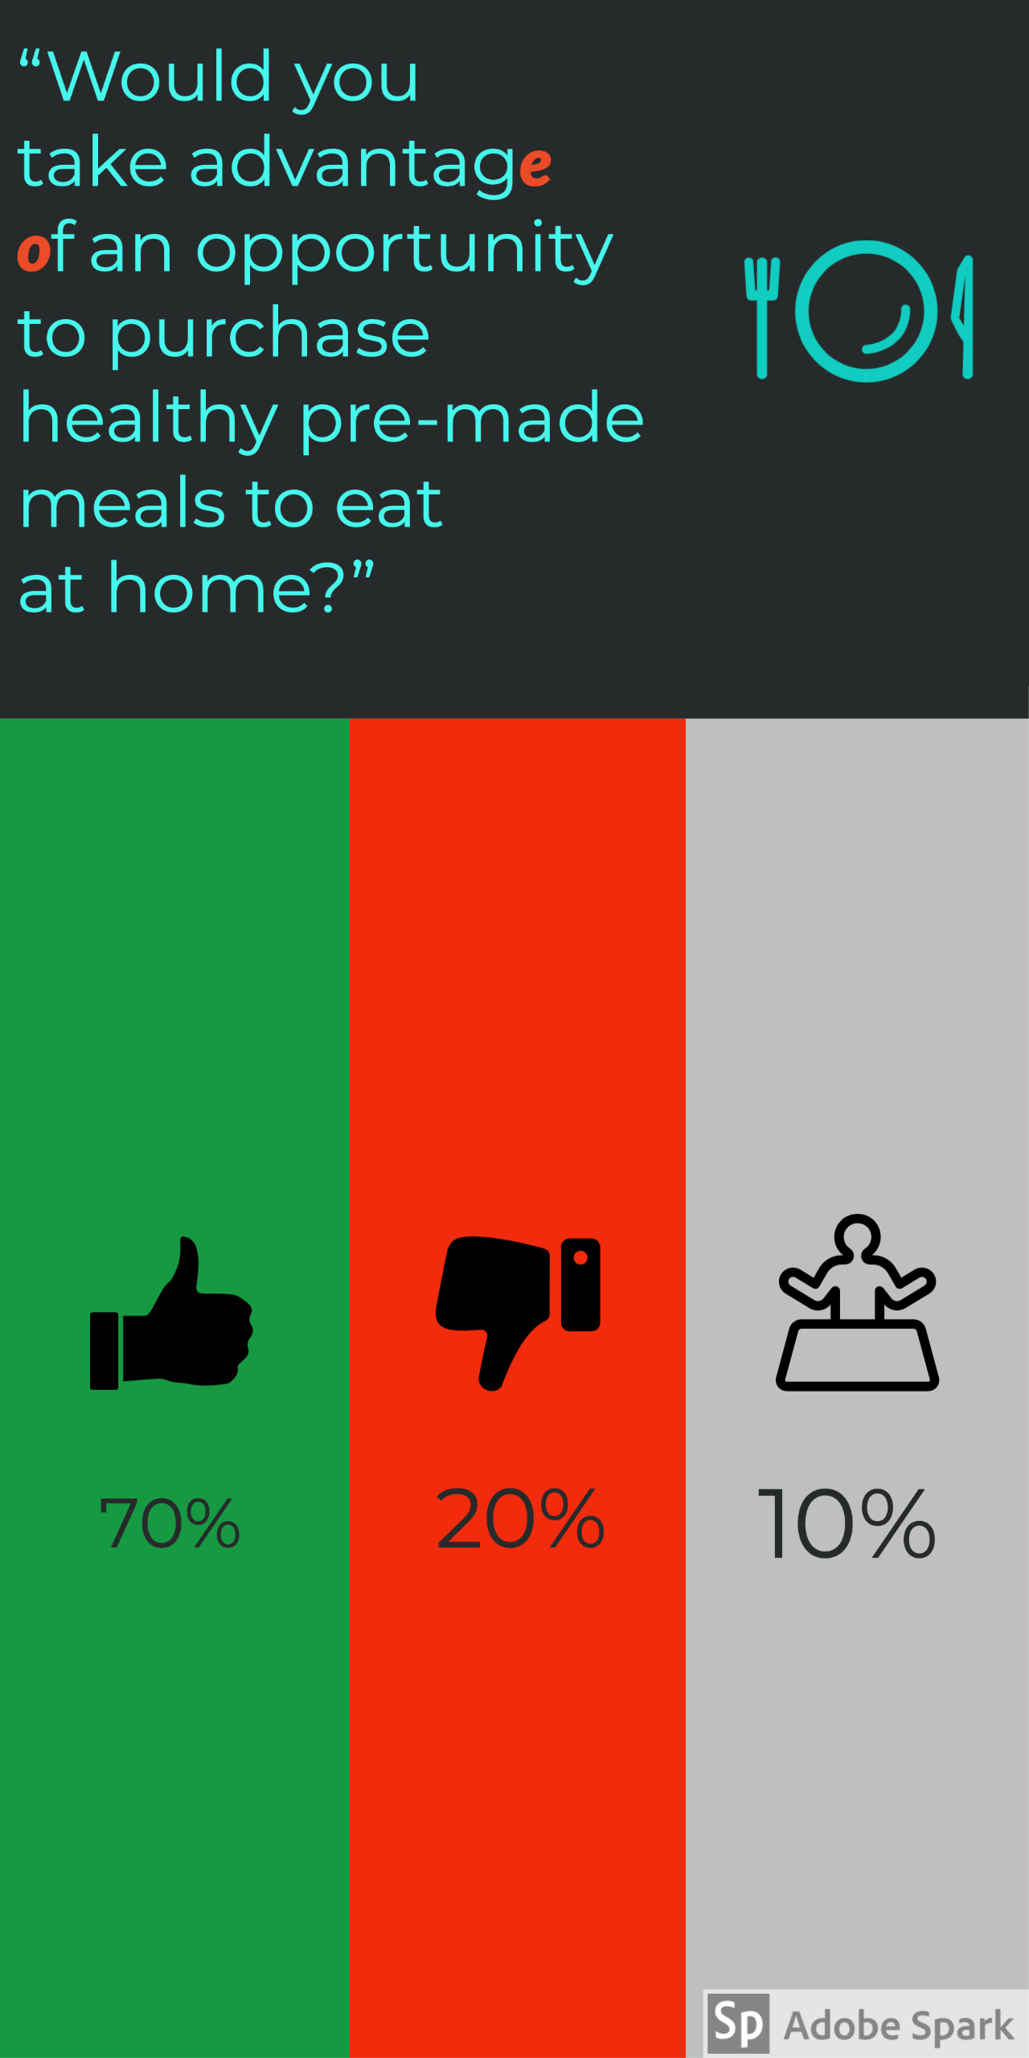 Ω
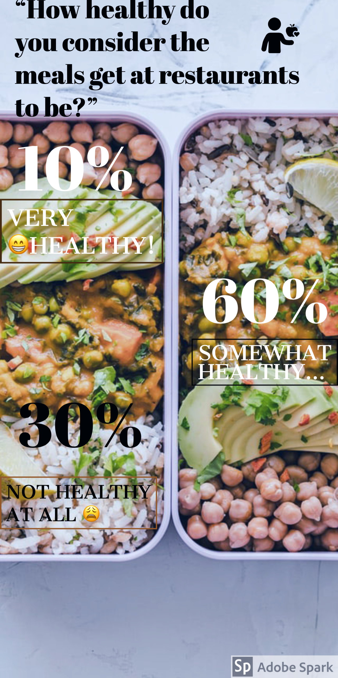
Conclusion
In a story published in USA Today, “72% of surveyed Millennials have made a conscious decision to stay single for a period of time,” (2018). This decision to not settle down equates to a decision to not slow down. Maintaining that way of life unfortunately means continuing to rush, work too much and continue poor eating habits. The media campaign for CJ’s Cookhouse will serve as a means to introduce this (and all) generations to an alternative to that narrative, providing a way to be health conscious while staying committed to their preferred way of life. While there may be detractors (read: older generations) who insist that the only way to improve your life overall is to follow the tried and true methods of years gone by, CJ’s will use their formula to improve lives without removing lifestyles.

REFERENCES

About Us. (2020). Retrieved from https://creativecuisinecolumbus.com/about-us/
About Us: Milo's Catering. (2020). Retrieved from https://www.cateringbymilos.com/about
African-American Female Millennial (Faith). (2020). Retrieved from https://www.lexingtonlaw.com/blog/credit-cards/how-to-pay-off-holiday-credit-card-debt.html
Carmichael, S. G. (2016, August 22). Millennials Are Actually Workaholics, According to Research. Retrieved from https://hbr.org/2016/08/millennials-are-actually-workaholics-according-to-research
Fryrear, A. (2019, September 19). What's a Good Survey Response Rate? Retrieved from https://www.surveygizmo.com/resources/blog/survey-response-rates/
Millennial's Eating Habits are Revolutionizing Food Logistics. (2019, April 30). Retrieved from https://www.smithcorona.com/blog/millennials-changing-food-logistics/
Miller, R. W. (2018, October 8). Are Millennials 'killing' relationships, too? Young people are embracing single life, Tinder finds. Retrieved from https://www.usatoday.com/story/news/nation-now/2018/10/08/millennials-tinder-survey-single-life-dating-relationships/1535860002/
Our Story: Marigold Catering – Cleveland, OH: Weddings, Corporate Events, Parties. (2020). Retrieved from https://www.marigoldcatering.com/our-story/
Oyedele, A. (2018, March 5). How Millennials Are Changing the Food Industry. Retrieved from https://www.inc.com/business-insider/millennials-food-industry-preferences-eating-out-restaurant-prepared-meals-catering.html
Simmons, C. J. (2018). CJ's CookHouse. Retrieved from https://www.facebook.com/CJsCookHouse/
Stanley, B. (2019, July 19). 7 Tips to Increase Brand Awareness Using Social Media Channels. Retrieved from https://www.relevance.com/7-tips-to-increase-brand-awareness-using-social-media-channels/

